6 KUBERNETES

Docker Challenges :
There is no failover method for docker host
There is no failover method for docker containers
There is no proper autoscaling features in docker
There is no proper application upgrade mechanism in docker host
There is no container – auto roll back in docker host.

Docker swarm : supports only docker container
Kubernetes : Orchestration tool
Supports any container
Developed by Google and maintained by CNF ( Cloud Native Foundation )

- What is Docker? 🐳
- Docker is a containerization tool.
- It is mainly used to : Build applications into containers
  - Package app + dependencies together
  - Run apps consistently on any system

- Docker = “How to create & run containers”

- Key points : Creates Docker images, Runs containers,
  - Good for single server / small setups
  - Easy to learn and use

- What is Kubernetes? ☸️
- Kubernetes is a container orchestration tool.
- It is used to : Manage many containers
  - Run containers across multiple servers (nodes)
  - Handle scaling, load balancing, self-healing

- Kubernetes = “How to manage containers at scale”

- Key points : Manages Docker (or containerd) containers
  - Automatically restarts failed containers
  - Scales apps up/down
  - Used in production environments

- Difference between Docker and Kubernetes
Feature | Docker | Kubernetes
Purpose | Create & run containers | Manage containers
Scope | Single machine | Multi-node cluster
Scaling | Manual | Automatic
Load Balancing | Limited | Built-in
Self-healing | ❌ | ✅
Learning Curve | Easy | Steep
Used in Production | Small apps | Large, enterprise apps

Azure : AKS
AWS : EKS
GCP : EKE

We can auto scale pods
With timing of 20 or 50%

Master node and worker node
In kubernets we call them as pods

If one container fails then pods switch to different container and continues
Self healing capacity :
If one container is down automatically another container creates and runs the applications

If pods creates automatic and container is not enough with present
Then container get increase and increases pods will be created in new container

We can upgrade using blue green deployment
if pod is having old version and another with new version
Just changed weightage to new with 100
Then requests will forward to new branch if there is any issue
Then again upgrade old with 100 weightage then requests move to old
Using help charts we can upgrade and roll back

Kubernetes can be installed
- IaaS :
VM1 : Kubernetes Master
VM2 : Kubernetes pod, install docker engine
VM3 : Kubernetes pod, install docker engine

- Minikube : worker node
Require high ram and cpu

cloud : AKS
inbuild aks we have
we have master node and worker node
using kubectl commands

Components :
Worker node : docker host ( by default docker is installed
No need of separate install ment
Pod : it is a smallest object in Kubernetes and it is abstract
Inside pod container will be there
Pod can be shifted to any container depends on requirement
IP : every pod has IP, this ip will be attach to life cycle of the pod
If one pod get crashed or deleted then one more pod is created with different ip
So again configuration need to be done for communication to avoid this
Services :
Cluster IP : Internal ip, internal communication
Node port : external communication
Load balancer : external communication
Ingress : external communication

When we want to login we login to pod and make configuration changes but always it Is hectic
Hence when we use config map all the configuration of application (port version installment etc ) written in config map along with pod and which are created based on config map

Config map :
Secrets : it is encrypted

Class 2 intro
Kubernetes : container orchestration tool
Master node and Worker node : docker host
Pod : it has container
Pod is smallest object
Pod has own ip
Service is type of a load balancer
- Cluster ip
- - lb node part, ingress

Config map for pod creation
Config map is created using variables

Kubernetes architecture
AKS - K8s :
Api server :
Etcd : internal data base
Contains all cluster inf

Controller

- Kubernetes
- Cloud Native Computing Foundation maintains Kubernetes.
- Kubernetes (K8s) is an open-source container orchestration platform.

- What It Does
  - Manages containers across multiple servers, Auto-scaling, Self-healing
  - Load balancing, Rolling updates

- Important
  - Not a cloud service
- You must install & manage : Control plane, Worker nodes, Upgrades, Security

- Kubernetes = Orchestration software.

- AKS (Azure Kubernetes Service)
- AKS is provided by Microsoft Azure.
- It is a managed Kubernetes service.

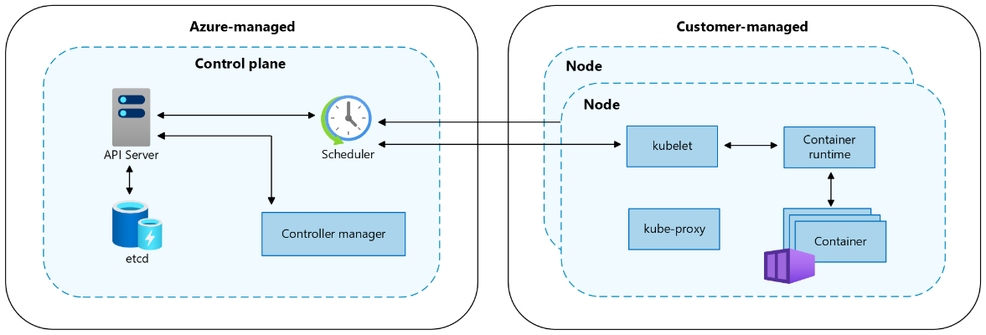

- Azure Manages : Control plane, Master nodes, Upgrades, Security patches
- You manage : Worker nodes, Applications

- AKS = Managed Kubernetes in Azure.

- EKS (Elastic Kubernetes Service)
- EKS is provided by Amazon Web Services.
- It is also a managed Kubernetes service.

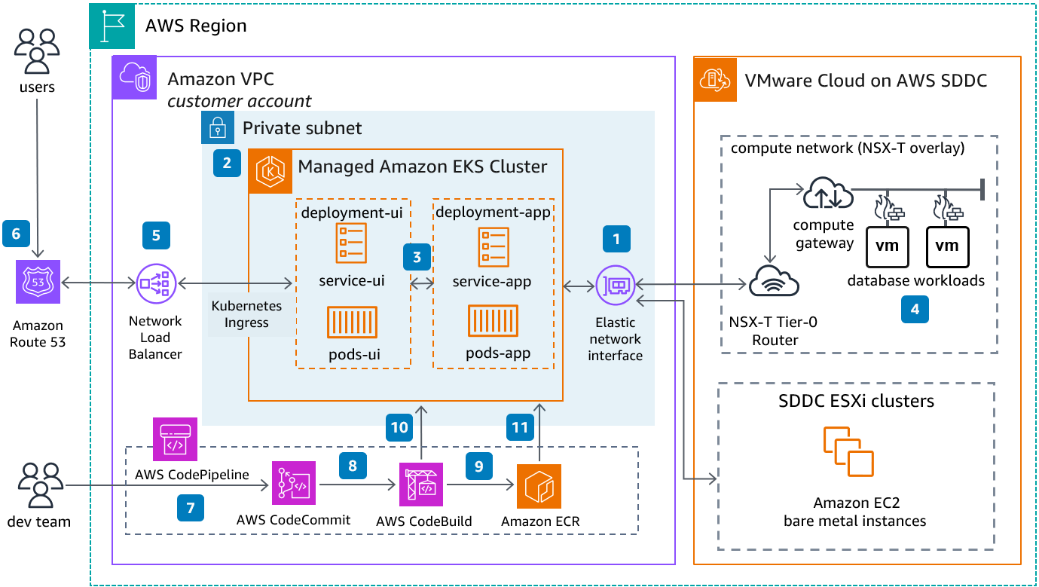

- AWS Manages : Control plane, High availability, Patching

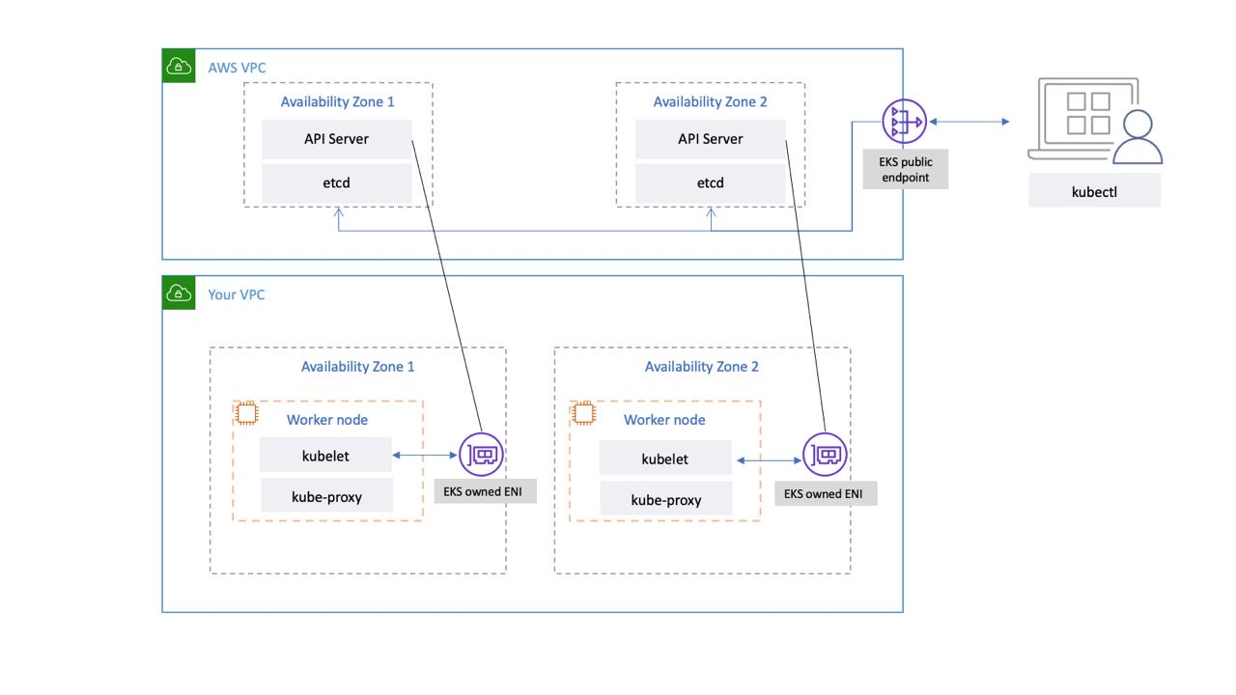

- You manage : Worker nodes (EC2 or Fargate), Applications

- EKS = Managed Kubernetes in AWS.

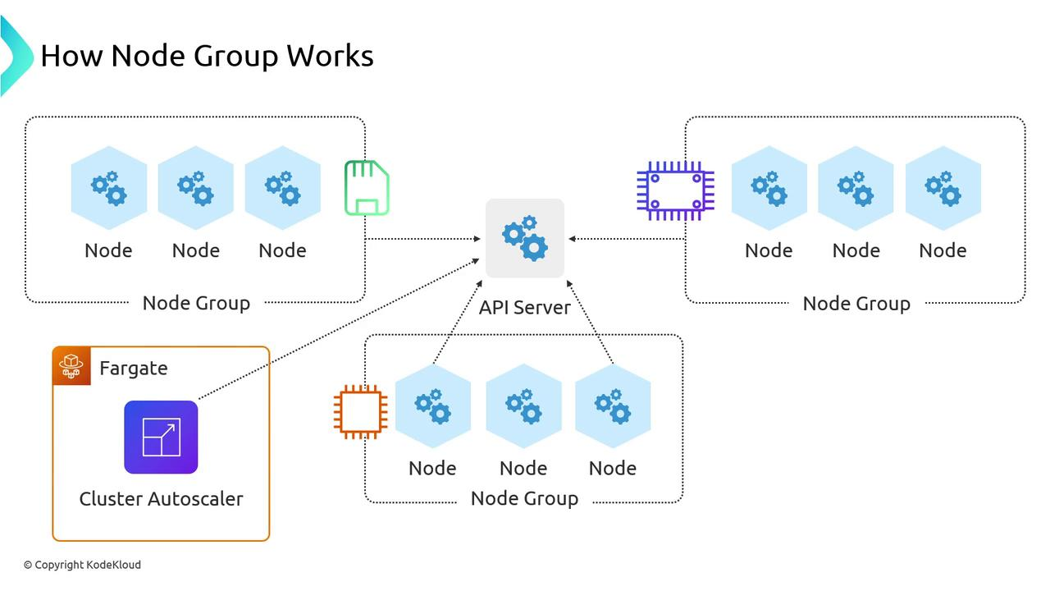

- Main Differences
Feature | Kubernetes | AKS | EKS
Type | Open-source software | Managed K8s | Managed K8s
Cloud Provider | None | Azure | AWS
Control Plane | You manage | Azure manages | AWS manages
Setup Complexity | High | Low | Medium
Cost | Infra cost only | Mostly worker node cost | Control plane cost + worker cost

- Simple Real-Time Understanding
- If you install Kubernetes manually on VMs → That is Kubernetes.
- If you use Azure and don’t want to manage master nodes → Use AKS.
- If you use AWS and want managed Kubernetes → Use EKS.

- Interview Answer
- Kubernetes is an open-source container orchestration platform.
- AKS and EKS are managed Kubernetes services provided by Azure and AWS respectively,
- where the cloud provider manages the control plane and reduces operational complexity.

- KUBERNETES ARCHITECTURE
- Kubernetes architecture is divided into two main parts:
  - Control Plane (Master Node)
  - Worker Nodes

- 🧠 Brain → Control Plane
- 💪 Workers → Worker Nodes

- Control Plane (Brain of Kubernetes)
- The Control Plane manages the entire cluster.
- Main Components:
- API Server : Entry point of the cluster
- All commands go through this
- Communicates using REST API

- Etcd : Distributed key-value database
- Stores cluster state (pods, nodes, config)
- Brain memory of Kubernetes

- Scheduler :
- Decides which Worker Node will run a Pod
- Checks CPU, memory, availability

- Controller Manager
- Ensures desired state = actual state
- If Pod crashes → creates new Pod
- Handles replication

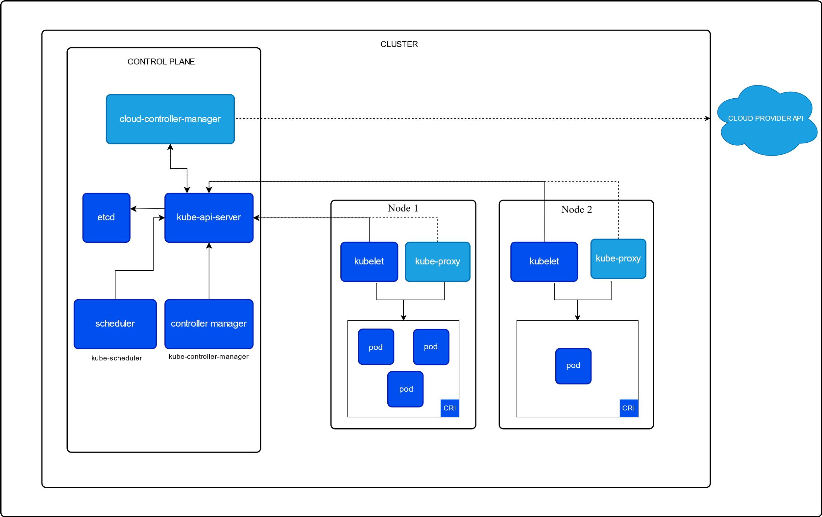

- Worker Node (Execution Layer)
- Worker Nodes actually run the applications.
- Components :

- Kubelet : Agent running on each node
- Communicates with Control Plane
- Ensures containers are running

- Container Runtime : Runs containers
- Example: Docker or containerd

- Kube-Proxy : Manages networking
- Maintains service communication
- Handles load balancing between Pods

- Pods : Smallest deployable unit
- Contains one or more containers
- Shares network and storage

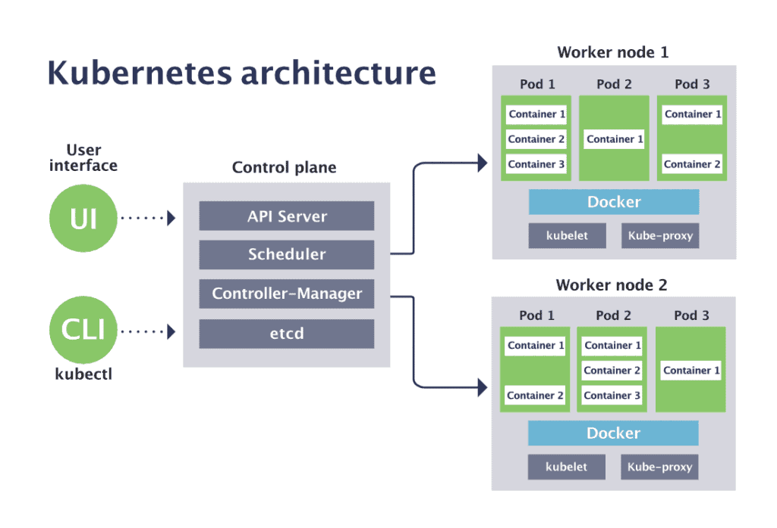

- Kubernetes Internal Architecture

- Complete Internal Workflow (Step-by-Step)
Example : kubectl apply -f deployment.yaml

- Step 1: User Request
- User sends request via kubectl
- → Request goes to API Server

- Step 2: Validation & Storage
- API Server : Authenticates request
- Validates YAML
- Stores configuration in etcd

- Step 3: Controller Reaction
- Controller Manager : Detects new Deployment
- Creates ReplicaSet
- Creates Pod objects

- Step 4: Scheduling
- Scheduler : Finds best Worker Node
- Assigns Pod to that node

- Step 5: Pod Creation
- On selected Worker Node:
- Kubelet receives instruction
- Pulls image via Container Runtime
- Creates Pod
- Starts containers

- Step 6: Networking
- Kube-Proxy : Updates routing rules
- Enables Service communication

- Step 7: Continuous Monitoring
- Controller keeps checking:
- If Pod crashes → recreate
- If Node fails → reschedule
- If replicas mismatch → adjust

- This continuous monitoring is called Control Loop Architecture

🏗 Internal Architecture Diagram (Text View)
User (kubectl)
│
▼
API Server
│
▼
etcd
│
▼
Controller Manager
│
▼
Scheduler
│
▼
-----------------------------
| Worker Node |
| ┌─────────────────────┐ |
| │ Kubelet │ |
| │ │ │ |
| │ Container Runtime │ |
| │ │ │ |
| │ Pod │ |
| │ (Containers) │ |
| │ │ |
| │ Kube-Proxy │ |
| └─────────────────────┘ |
-----------------------------

🔥 Key Internal Concepts (Interview Points)
✔ Declarative configuration
✔ Desired vs Actual state
✔ Reconciliation loop
✔ API-driven architecture
✔ Distributed datastore (etcd)
✔ Control Plane vs Worker separation
✔ Self-healing & Auto-scaling

🎯 One-Line Interview Answer
Kubernetes internal architecture consists of a Control Plane that manages cluster state through API Server, Scheduler, Controller Manager, and etcd, and Worker Nodes that execute Pods using Kubelet, Container Runtime, and Kube-Proxy, maintaining desired state through a continuous reconciliation loop.

Worker node :
Pod : multiple containers can be have
Has own ip if pod delete ip delete

To avoid this
We use Service
- Internal Cluster ip
- External - Load balancer, node port, ingress

When ever we create pod we use Config map for default values
Config map is created using env variables

K8s
Aks

pod is container
pod has ip
when pod dies ip also deletes
to avoid we use service
s1 : cluster
s2 : node balancer, node port, ingress

config map : whenever we create pod we use config map to add default values
config map is created using env variables

architecture
Master node :
Api server : all request from outside received
Etcd : to store data ( internal database )
Having all cluster information

Scheduler : it will assign pods to worker nodes
Controller : all combinations of multiple controller

Worker node :
Kubelet : from master node to worker node infor received
It is responsible for download image and start container

Kube proxy :
Contains all inf of pod related
If any one trying to access pod
Inf received by kubelet and send to kube proxy

In worker node container engine is mandatory
By default aks docker engine is present

For managing
We use kubectl commands is deep
In aks we can use Jio method but it is limited

Azcli commands for azure login
Kubectl commands

Aks credentials
Aks is manage using kubectl commands

By default azure load balancer is created
Pip is generated automatic

Kubernetes practical

Basics :-
Search Kubernetes in search bar
New -> add kube cluster

Leave as it is
Automatic patch schedule : no schedule
Authorization and authentication : local accounts with rbac

Kubernetes is free
But worker node is created
Vm is billed hence partially free
partially paas model

Use d version cpu
As b version is not supporting

Use a vm and run commands
Apt update
curl -sL https://aka.ms/InstallAzureCLIDeb | sudo bash

install kubectl commands
curl -LO "https://dl.k8s.io/release/$(curl -L -s https://dl.k8s.io/release/stable.txt)/bin/linux/amd64/kubectl"

for installing kubectl
sudo install -o root -g root -m 0755 kubectl /usr/local/bin/kubectl

provide execution permission : chmod +x kubectl
create a parent folder with local bin : mkdir -p ~/.local/bin
move kube ctl to that folder : mv ./kubectl ~/.local/bin/kubectl

for checking version : kubectl version --client

this vm is not worker or master node
it is just a platform to manage Kubernetes

use : az login --use-device-code

Copy web link http – device and paste in web url
paste the code shown in line
And continue

Now type the default or your subscription where Kubernetes is present or you want to use

Start the cluster if it is stopped
Download credentials :
Open azure portal and click on connect you will find credentials downloads copy link and run in vm

Before you run commands make sure Kubernetes is running else it will throw error
For getting pods : kubectl get pods
For getting nodes ( backend pools or worker nodes ) : kubectl get nodes

Create a file with extension .yml
For nginx deployment in yaml file

apiVersion: apps/v1
kind: Deployment
metadata:
name: nginx-deployment
labels:
app: nginx
spec:
replicas: 2
selector:
matchLabels:
app: nginx
template:
metadata:
labels:
app: nginx
spec:
containers:
- name: nginx-container
image: nginx:latest
ports:
- containerPort: 80

For creating and deploying pods : kubectl apply -f <filename>.yml
Now check pods : kubectl get pods

Now write one more file for service to get ip
apiVersion: v1
kind: Service
metadata:
name: nginx-service
spec:
type: LoadBalancer
selector:
app: nginx
ports:
- protocol: TCP
port: 80
targetPort: 80

LoadBalancer type as it is as it is caseSensitive

To delete : kubectl delete <servicename>

To deploy app in the form of containers
In worker node
Kubernetes does not deploy directly on worker nodes
In worker node -> pod -> app
In pod only one application get runs

Pods generally have one to one relationship with containers
To scale up we create pod
To scale down we delete pod

In a pod same kind of containers can not run
Only different containers like helper containers

We can have multiple containers in same pod but with different containers
Rare case as one pod multiple containers : as it uses same network and same storage
For info : kubectl get nodes
For getting extra inf : kubectl get nodes -o wide

For creating pod : kubectl run <desirecpod> --image <container image>
Ex : kubectl run firstpod –image nginx

kubectl describe pod <posname>
for detailed info to troubleshoot

we can use alias names as
kubectl get po
kubectl get svc

KUBERNETES SERVICE LOAD BALANCER

When a cluster is created
A load balancer will be created with public ip
This pip is managed ip as to connect with pod
We can expose an app running on a set of k8s using different types of services

Cluster ip service ( internet to k8s cluster )
Node port service,
Load balancer service,
Ingress service.
To internet.

If I use load balancer as a service it will not create a lb
Just ip is created

For creating pod : kubectl run <desirecpod> --image <container image>
Ex : kubectl run firstpod –image nginx

For exposing pod : kubectl expose pod <podname> --type=LoadBalancer --port=80 --name=<servicename>

Podname = While creating pod which name you given provide same name which you want to expose
Type = service type
Port = port number of application
Service name = any name

For getting ip to check : kubectl get svc
Or kubectl get service
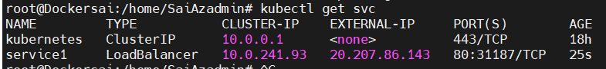

For describing service : kubectl describe service <servicename>

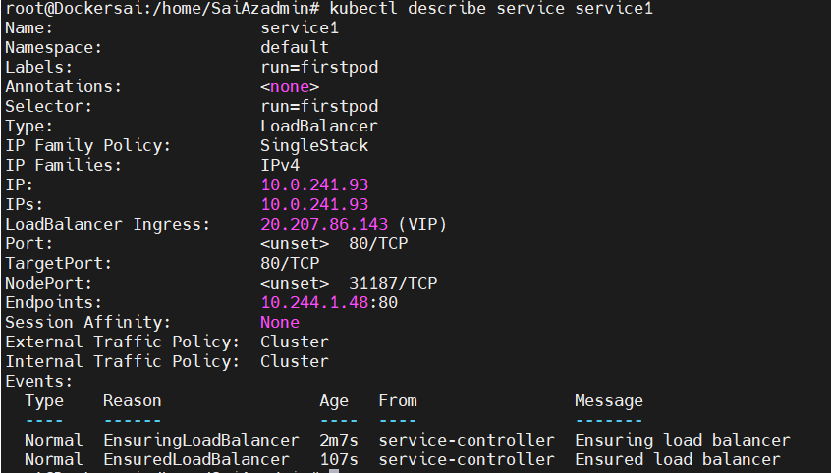

For getting logs and pod history : kubectl logs <podname>
For getting live logs and update who is accesing : kubectl logs -f <podname>

This can be use ful for trouble shooting also
Use this link for reference : https://kubernetes.io/docs/reference/kubectl/quick-reference/
For entering or logging into pod : kubectl exec -it <podname> -- /bin/bash
Env for environment variables : env

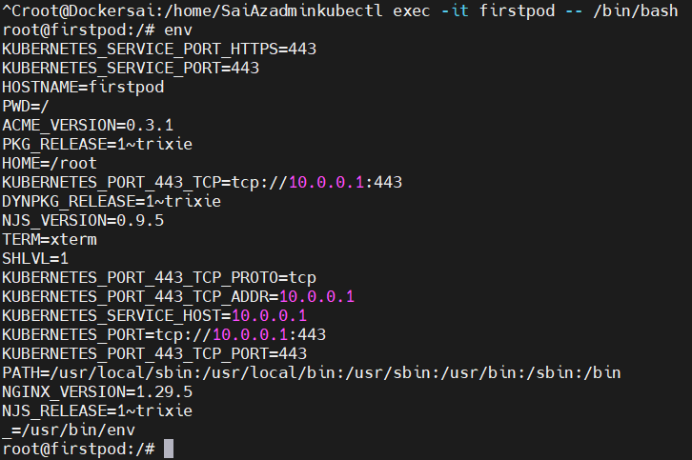

For exiting : exit
For checking pod details without entering : kubectl exec -it <podname> -- env

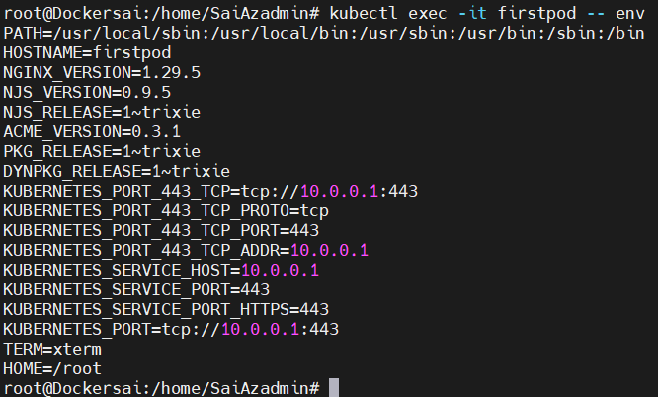

To get pod yaml file inf : kubectl get pod <podname> -o yaml
To get service yaml inf : kubectl get service <podname> -o yaml

To delete a pod or service : kubectl delete <service name>

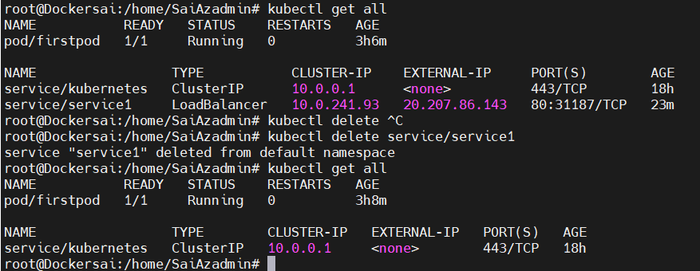

KUBERNETES REPLICA SET

Replica set is used for
high availability or reliability : if pod are not available it will automatic create new pod
scaling : for increasing or decreasing pod depends on load and requirement.
Load balancer
Labels and selectors : key items which ties all 3 together

Replica set is used to maintain the stable set od replica pod at a given time
If pod crashes it will recreate the pod immediately to ensure configure number of pods

We use load balancer to avoid heavy traffic on single pod

Kube provide pod load balancer out of box using services for pod
Which are part of replica set

Scaling is when load is becoming too much pod is increasing as per need

To create a replica set
Let us write a yaml file using nginx image
apiVersion: apps/v1
kind: ReplicaSet
metadata:
name: nginx-replicaset
labels:
app: nginx
spec:
replicas: 3
selector:
matchLabels:
app: nginx
template:
metadata:
labels:
app: nginx
spec:
containers:
- name: nginx-container
image: nginx:latest
ports:
- containerPort: 80

For creating or applying : kubectl apply -f <filename>
For getting pods : kubectl get pods

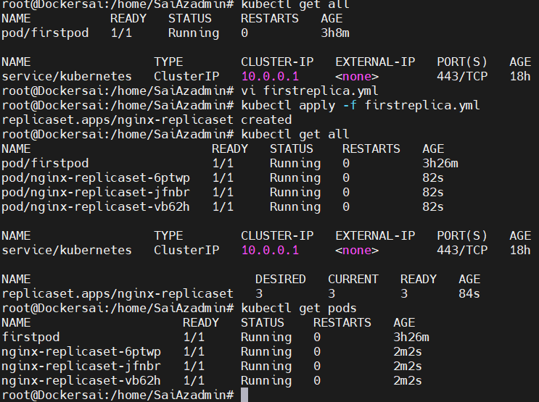

We can check in azue portal also
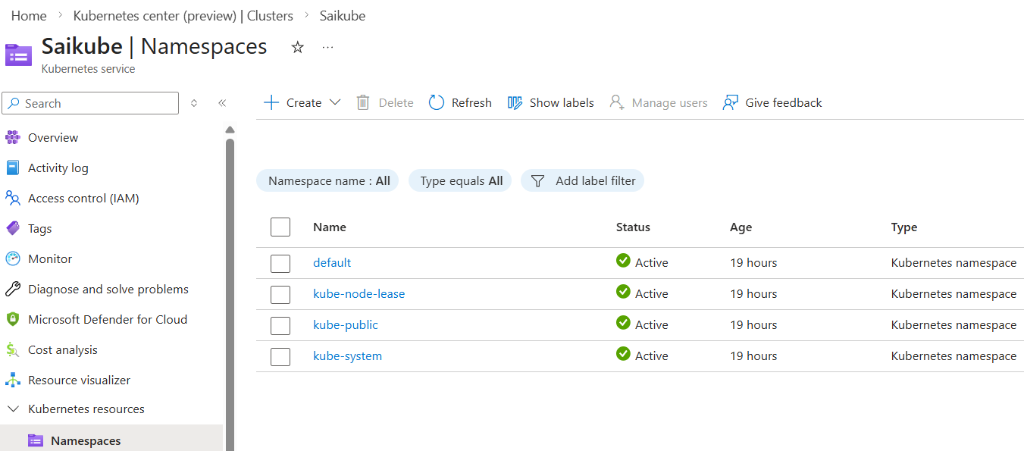

For deleting pod : kubectl delete pod/<podname>
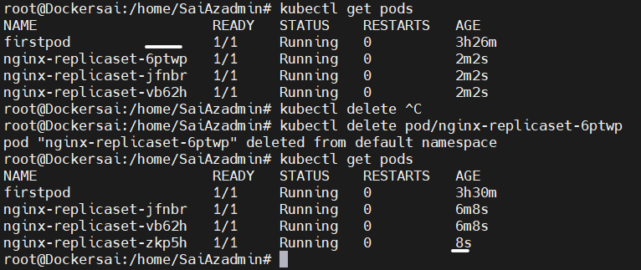

When pod is deleted it will automatically create a pod

For checking replica set : kubectl get rs
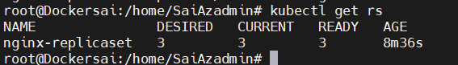

For describing replica set : kubectl describe rs/nginx-replicaset

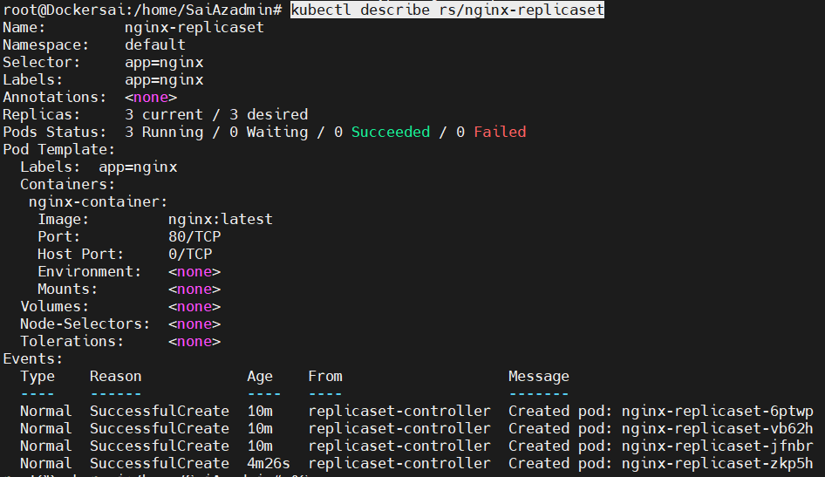

For pod describing : kubectl describe pod <podname>
kubectl describe pod nginx-replicaset-jfnbr

for pod owner : kubectl get pod <podname> -o yaml

for exposing pod : kubectl expose rs <replicasetname> --type=LoadBalancer --port=80 --target-port=80 --name=<servicename>

for deleting : kubectl delete <rsname>

Yaml file is written in key value pairs

Mandatory
apiVersion: v1
kind: pod
metadata:
name: nginx-pod
labels:
app: nginx
spec:
containers:
- Name: nginx
- Image: nginx
- Ports :
  - Containerport:80

--- for saparator
Two document in one file using saparator

depends on kind api version changes

4. KUBERNETES SERVICE INGRESS

We can create yaml files using command mode
kubectl create deploy myapp --image nginx --dry-run -o yaml > deployment.yaml

after deployment
name can be anything ex myapp
file naming can be anything

We can create yaml files to expose pod using command mode
kubectl expose deploy myapp --port 80 --type=LoadBalancer --dry-run -o yaml > service.yml
make sure provide same pod name

we can create yaml files from azure portal/GUI also
open Kubernetes -> kebernetes resources -> workloads -> create yaml file -> type code -> apply
create

NAME SPACE
It is a logical grouping where we can create groups and create pods in it
When we run group commands only pods present init details are retrived

When we create group known as namespace and create pods
And run command kubectl get pods
This command wont work
Kubectl get --namespace <namespacename>
Then it will retrive
Communication and networking is managed
Permisiions are also provided for security

To get name space details : kubectl get namespace
kubectl get ns

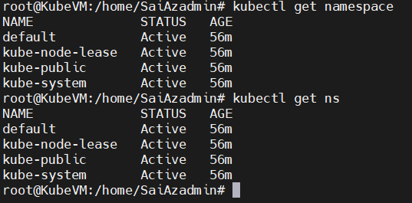

For creating name space : kubectl create namespace ns1
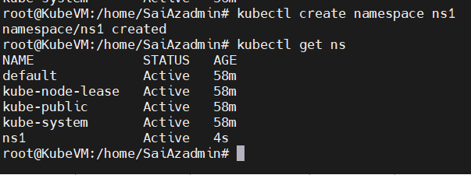

For creating service or deploying yaml in namespace :
kubectl apply -f deployment.yaml --namespace ns1

for getting pods info created in name space
kubectl get pods --namespace <namespacename>

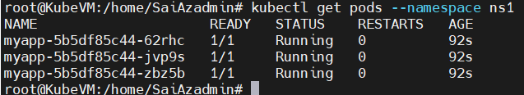

In it or company it is mandatory to ask name space

To delete : kubectl delete <podname> --namespace <name space name>

- Different container in a pod
In a pod we have only one container
If one more is there it must be different container
It is known as helper container or side car container or supporting container

When I deploy nginx in a container I want in web as : hi sai / hi
But nginx should not do this work
Soo we create support container

We will create a volume as it shares to all containers
Main container will have one path
Support container will have one path

Main container path is overwritten as support container and support container content will be visible
Main container is working but path is different one

- INGRESS
It is application gateway
It can route traffic based on url

Ex : if we create multiple applications we need multiple load balancers
To avoid it we use ingress it routes traffic based on url

Simple : multiple application -> one load balancer known as ingress -> traffic based on routing
Ex : main home page : /
Nginx : /nginx
Httpd : /httpd

We will write ingress in yaml file and deploy it
Ex :

apiVersion: apps/v1
kind: Deployment
metadata:
name: hello-deployment
spec:
replicas: 1
selector:
matchLabels:
app: hello
template:
metadata:
labels:
app: hello
spec:
containers:
- name: hello
image: hashicorp/http-echo
args:
- "-text=Hello World"
ports:
- containerPort: 5678

---
apiVersion: v1
kind: Service
metadata:
name: hello-service
spec:
selector:
app: hello
ports:
- port: 80
targetPort: 5678
type: ClusterIP

---
apiVersion: apps/v1
kind: Deployment
metadata:
name: nginx-deployment
spec:
replicas: 1
selector:
matchLabels:
app: nginx
template:
metadata:
labels:
app: nginx
spec:
containers:
- name: nginx
image: nginx
ports:
- containerPort: 80

---
apiVersion: v1
kind: Service
metadata:
name: nginx-service
spec:
selector:
app: nginx
ports:
- port: 80
targetPort: 80
type: ClusterIP

---
apiVersion: apps/v1
kind: Deployment
metadata:
name: httpd-deployment
spec:
replicas: 1
selector:
matchLabels:
app: httpd
template:
metadata:
labels:
app: httpd
spec:
containers:
- name: httpd
image: httpd
ports:
- containerPort: 80

---
apiVersion: v1
kind: Service
metadata:
name: httpd-service
spec:
selector:
app: httpd
ports:
- port: 80
targetPort: 80
type: ClusterIP

---
apiVersion: networking.k8s.io/v1
kind: Ingress
metadata:
name: app-ingress
annotations:
nginx.ingress.kubernetes.io/rewrite-target: /
spec:
ingressClassName: nginx
rules:
- http:
paths:
- path: /
pathType: Prefix
backend:
service:
name: hello-service
port:
number: 80
- path: /nginx
pathType: Prefix
backend:
service:
name: nginx-service
port:
number: 80
- path: /httpd
pathType: Prefix
backend:
service:
name: httpd-service
port:
number: 80

- HELM CHARTS

Helm charts is package manager of Kubernetes

myapp-chart/
│
|-----.helmignore # contains patterns to ignore when packaging helm charts
├── Chart.yaml # information about your charts (name, version etc)
├── values.yaml # the default values for your templates
├── charts/ # directory of sub charts that this charts depends on
├-── templates/ # the directory containing the actual Kubernetes yaml templates
| ├── deployment.yaml # a sample Kubernetes deployment manifest
| ├── service.yaml # a sample Kubernetes service manifest
| ├── ingress.yaml # a sample Kubernetes service manifest
| ├── _helpers.tpl # a location for shared template helpers/partials
|
|── tests/
|── test-connection.yaml

Chart.yaml : contains information of api, charts, definition
Charts folder : contains dependency file
Templates : will have actual yaml files
We may be using
Deployment.yaml files
Service.yaml for exposing
Ingress :

Values : for writing or storing values

- For installing helm charts :
curl -fsSL https://packages.buildkite.com/helm-linux/helm-debian/gpgkey | gpg --dearmor | sudo tee /usr/share/keyrings/helm.gpg > /dev/null

curl -fsSL -o get_helm.sh https://raw.githubusercontent.com/helm/helm/main/scripts/get-helm-4

chmod 700 get_helm.sh

./get_helm.sh

For creating charts : helm create <chart name>
Type : tree for tree structure

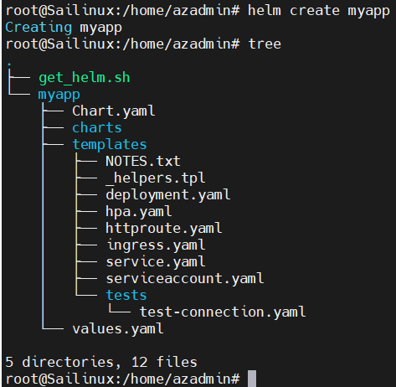

In myapp -> in chart.yaml we have definition
apiVersion: v2
name: myapp1
version : 0.1.0
appVersion: 1.0
description : A Helm chart for kubernetes

Now create templates folder in myapp1

kubectl create deploy myapp1 --image nginx --dry-run -o yaml > deployment.yaml
templates/deployment.yaml
apiVersion: apps/v1
kind: Deployment
metadata:
labels:
app: myapp1
name: myapp1
spec:
replicas: 1
selector:
matchLabels:
app: myapp1
strategy: {}
template:
metadata:
labels:
app: myapp1
spec:
containers:
- image: nginx
name: nginx
resources: {}
status: {}

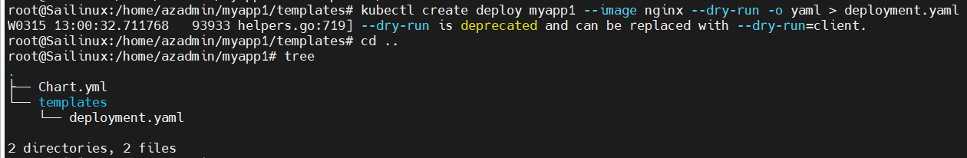

Now install myapp : helm install myapp1 .

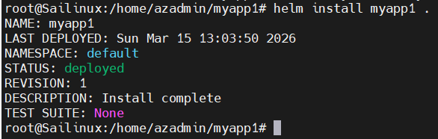

For checking history : helm history myapp1
If we change any version charts.yaml
Its show upgraded

For uninstalling : helm uninstall myapp1 .
For replica count in myapp1 create values.yaml file : vi values.yaml
replicaCount: 1

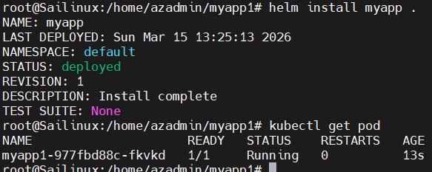

Upgrade replica count using command : helm upgrade myapp . --set replicaCount=3
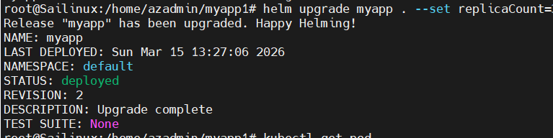

Sudo helm upgrade myapp1 . --values /tmp/myapp1.values

Official website of helm charts : https://helm.sh/
Readily available helm charts website : https://artifacthub.io/

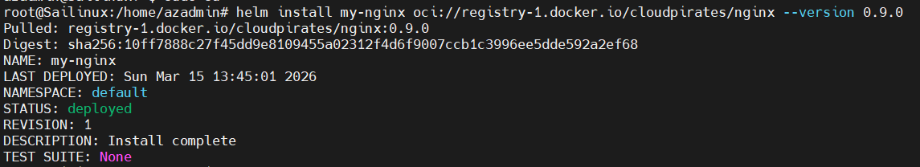

- Config maps

In this there would be some data
Using data pod gets created
When we create pods using this deployment.yaml files
It uses config maps and it will be created
We don’t need to login and give hard coded values manually

If we provide values via env values pod need to restart or redeploy again
Instead of that we can
If we mount values as volumes it automatically get changes

